INTERFACE DESIGN DOCUMENT
Name of Project: Electronic Device Helpdesk Support System (Bug Reporting & Telecom Support System)
List of forms to be created
- Document Name: Login Form (Login — Module 3.1 / UC 1)
  - Description: Provides role-based authentication allowing all 6 authorized system actors (Admin, Dispatch & Order Management Dept, Call Center Staff, Technical Support Team, Back End Mail Team, and Accounts Dept) to securely log into the Bug Reporting & Telecom Support System with appropriate department privileges.
  - Controls on the Document:
• Labels: Username, Password, Select Role
• TextBoxes: txtUsername, txtPassword (masked password input)
• ComboBox / Dropdown: cmbRole (Selects department role: Admin, Dispatch & Order, Call Center, Tech Support, Mail Team, Accounts)
• Command Buttons: btnLogin ('Login')
  - UI design:
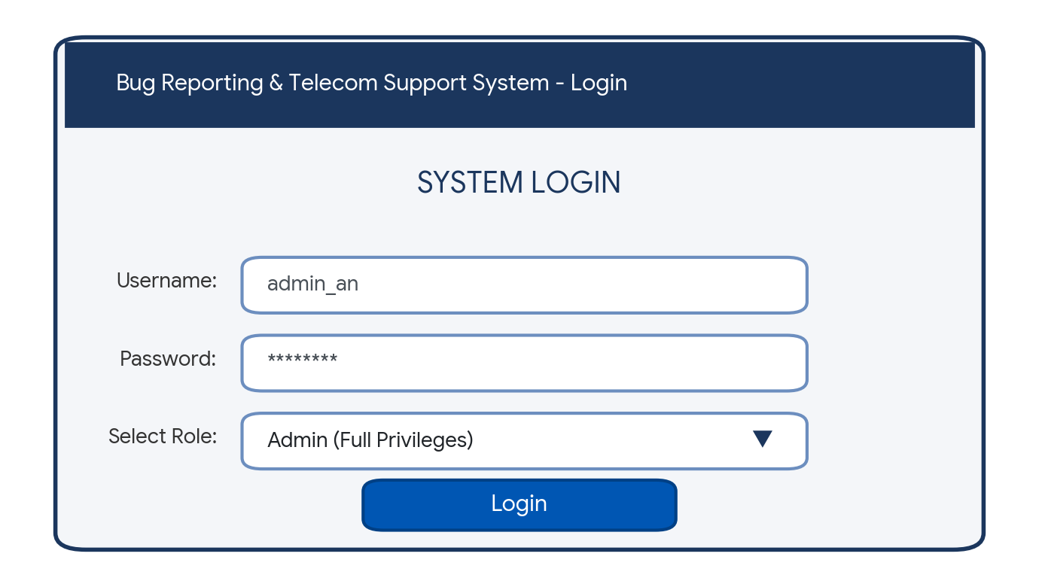
- Document Name: Lodge Complaint Form (LodgeComplaint — Module 3.3 / UC 6, 7, 8, 12)
  - Description: Enables Front End Call Center Staff and the Back End Mail Team (helpdesk@tele-comsupport.com) to look up customer orders/dispatches, verify warranty status and warranty card presentation, record or update complaint tickets, and automatically generate a sequential Complaint ID (e.g., CMP-01003).
  - Controls on the Document:
• Labels: Complaint ID, Order No, Dispatch No, Customer ID, Customer Info, Product Info, Warranty Card, Warranty Status, Fault Category, Intake Channel, Fault Description, Assign Tech, Service Charge
• TextBoxes: txtComplaintID (Read-only / Auto-generated sequential ID), txtOrderNo, txtDispatchNo, txtCustomerID (Read-only), txtFaultCategory, txtServiceCharge
• CheckBox: chkWarrantyCard ('Card presented by customer' — validates free warranty repair eligibility)
• ComboBoxes / Dropdowns: cmbIntakeChannel ('CALL_CENTER' / 'HELPDESK_MAIL'), cmbAssignTech (Selects Technical Support engineer)
• RichTextBox / TextArea: txtFaultDescription (Multi-line issue and fault details)
• Command Buttons: btnLookupOrder ('Lookup'), btnLookupDispatch ('Lookup'), btnSave ('Save Ticket'), btnClear ('Clear')
  - UI design:
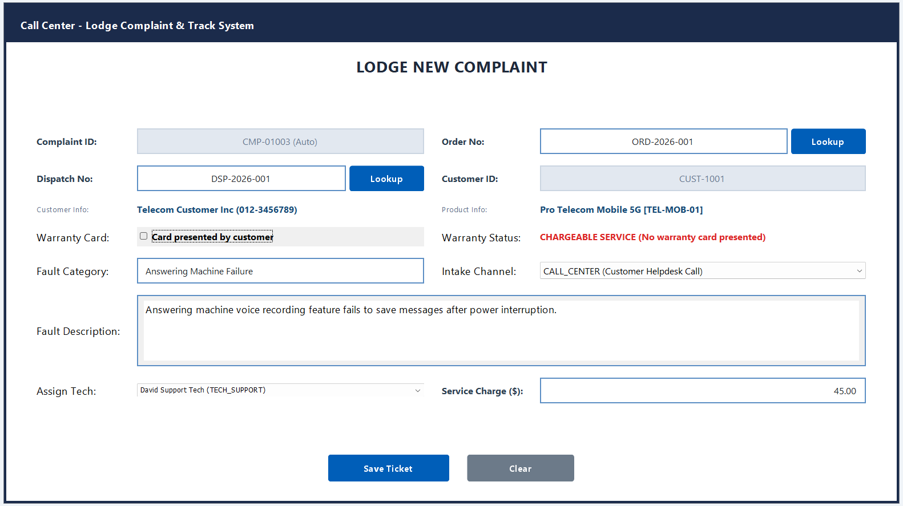
- Document Name: Order, Dispatch & Warranty Management Form (frmOrderDispatch — Module 3.2 / UC 2, 3, 4, 5)
  - Description: Allows the Dispatch & Order Management Department to create and update customer profiles (UC 4), record new telecom/electronic product orders or import Excel invoices (UC 2), generate a unique Dispatch Number linked to each order (UC 3), and define product-specific warranty terms and validity periods (UC 5).
  - Controls on the Document:
• Labels: Order No, Dispatch No, Customer ID, Customer Name, Phone / Email, Product Type, Order Quantity, Order Date, Shipping Date, Warranty Period, Warranty Dates, Delivery Address & Warranty Terms
• TextBoxes: txtOrderNo, txtDispatchNo (Read-only / Auto-generated unique to order), txtCustomerID, txtCustomerName, txtPhoneEmail, txtOrderQty, txtShippingDate, txtWarrantyDates (Read-only)
• ComboBoxes / Dropdowns: cmbProductType (Selects telecom product model & features), cmbWarrantyPeriod (12 / 24 / 36 Months)
• RichTextBox / TextArea: txtDeliveryAndWarrantyTerms (Shipping address and warranty policy terms)
• Command Buttons: btnImportExcel ('Import XLS'), btnSaveOrderDispatch ('Save Order & Dispatch'), btnClear ('Clear')
  - UI design:
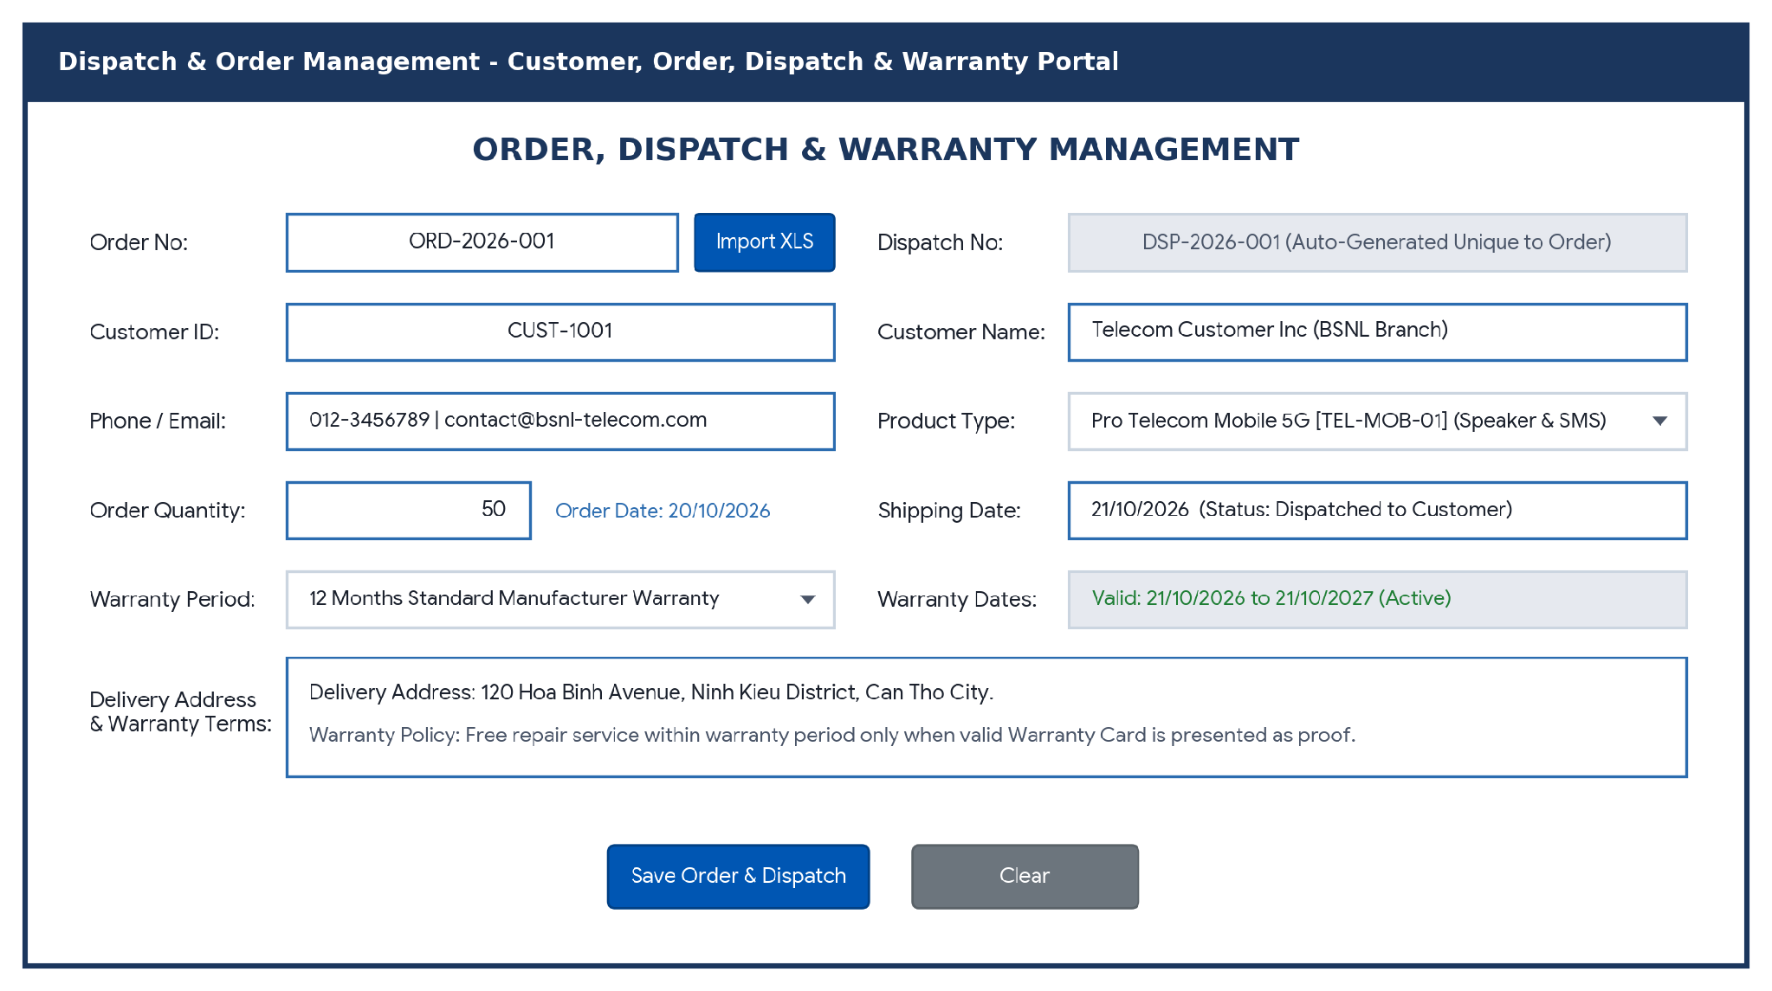
- Document Name: Technical Support & Service Charge Processing Form (frmTechSupport — Module 3.4 / UC 9, 10, 11)
  - Description: Allows the Back End Technical Support Team and Accounts Department to view the complete list of complaints logged till date (UC 9), verify warranty validity and warranty card proof, calculate out-of-warranty service charges (Part Cost + Labor Fee) (UC 11), and update complaint resolution statuses while strictly prohibiting complaint record deletion (UC 10).
  - Controls on the Document:
• DataGrid / Table: dgvComplaintQueue (Displays Complaint ID, Order No., Dispatch No., Product Type, Warranty / Card Status, and Current Status)
• Labels: Selected Ticket, New Status, Part Cost , Labor Fee, Total Charge Technical Notes & Resolution
• TextBoxes: txtSelectedTicket (Read-only summary), txtPartCost, txtLaborFee, txtTotalCharge (Read-only auto-calculated bill for Accounts Dept)
• ComboBox / Dropdown: cmbNewStatus (Pending, In Progress / Under Repair, Serviced / Resolved, Closed)
• RichTextBox / TextArea: txtResolutionNotes (Technical repair and diagnostic notes)
• Command Buttons: btnUpdateStatus ('Update Status & Save Bill'), btnClear ('Clear'), btnDelete ('Delete (Disabled)' — permanently disabled per non-deletion business rule)
  - UI design:
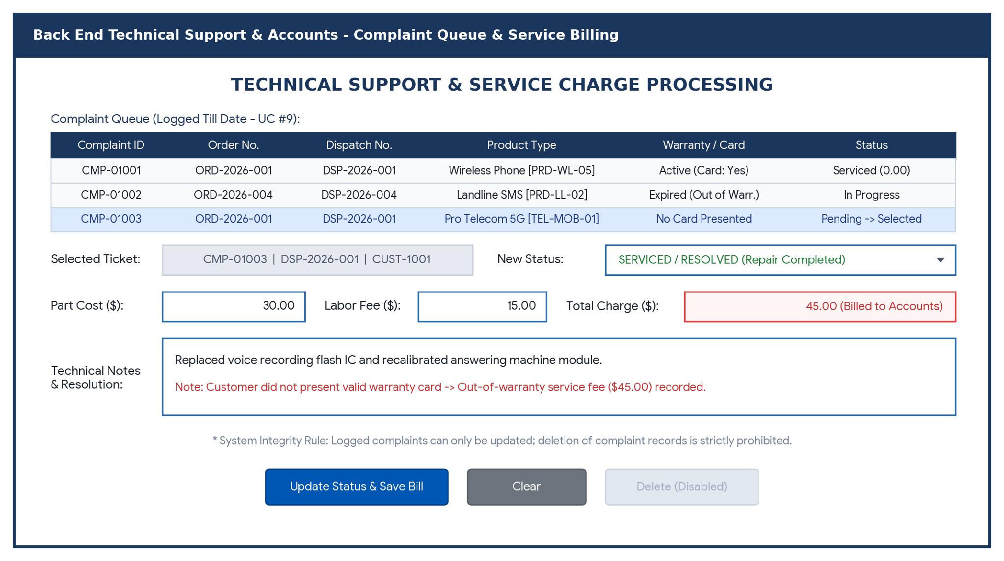
- Document Name: Record Tracking & Service Performance Analytics Dashboard (TrackingAnalytics — Module 3.5 / UC 13, 14, 15)
  - Description: Enables authorized staff (Admin, Dispatch & Order Dept, Call Center Staff, Technical Support Team) to track customer, order, dispatch, and complaint records by Order No., Dispatch No., or Complaint No. (UC 13), view complete chronological customer complaint histories (UC 14), and empowers the Admin to monitor complaint frequencies and staff resolution times via KPI cards, charts, and Excel exports (UC 15).
  - Controls on the Document:
• Search Controls: cmbSearchType ('Order / Dispatch / Complaint'), txtSearchKeyword, txtDateRangeFilter, btnTrack ('Track Record')
• KPI Summary Cards: lblTotalComplaints, lblResolvedCount, lblAvgResolutionTime, lblOutWarrantyRevenue
• DataGrid / Table: dgvCustomerComplaintHistory (Displays chronological complaints logged till date for the accessed customer)
• Visual Analytics Panel: pnlPerformanceCharts (Horizontal SLA bars comparing Call Center, Back End Mail Team, and Technical Support resolution metrics)
• Command Buttons: btnExportExcel ('Export Excel Report'), btnRefresh ('Refresh Metrics')
  - UI design:


